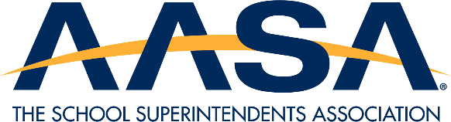

AASA VIRTUAL MENTAL WELLNESS COLLABORATIVE
BACKGROUND AND APPLICATION

Young people have experienced more than three years of pandemic-affected educational opportunities in addition to severe economic challenges, fear and depression, and grief and loss. AASA's members need strategies to support, bolster and develop mental wellness for our students and the adults that serve them. To that end, AASA is seeking four more districts to be a part of virtual collaborative to share best practices in mental wellness, positive youth development, avoiding/preventing risky behaviors and practices, and raising awareness of nicotine-derived products for school staff and students.

AASA will engage the four districts each year for focus groups, technical assistance, and coaching and network them in a virtual collaborative to share best practices (total of 8 districts over the two-year project period). Our team will visit each district to conduct a youth focus group on mental health/risky behaviors and will share data analysis with partners and the field.

Districts will participate in a one-day in-person meeting prior to the National Conference on Education (NCE) in February 2024 as well as a Youth Well-Being Summit in the Spring.

Selected districts will receive a stipend of $5,000 for their participation.

Applications are due November 15th! Districts will be notified of selection by December 1st. Please send completed applications to Kayla Jackson, kjackson@aasa.org.

District Information

Name:
Location (City and State):
Superintendent:
AASA Member: Y/N
Number of Students:
Demographics:
District Type: Urban/Suburban/Rural/Frontier

Please provide a brief overview of your district’s efforts to support mental wellness for students and staff (250 words or less).

